**WorkShop 2**

**(Viktor Makarov, Luca Novello, Joshua Mills (sick))**

Logic 1 - Pseudocode - Joshua Mills

1. Ask user to input which type of weather condition
   1. If value is MIXED weather condition, proceed to Step 2
   2. If value not MIXED proceed to step 7
2. Ask user to input Precipitation Accumulation (AP) in cm
   1. If value is (<=3.5 cm) proceed to step 7
   2. If value is (>3.5 cm - 5.75 cm) proceed to step 3
   3. If value is (>5.75 cm - 16.5 cm) proceed to step 4
   4. If value is (>16.5 cm - 40.0 cm) proceed to step 5
   5. If value is (>40.0 cm proceed) to step 6
3. (>3.5 cm - 5.75 cm) Ask user to input Temperature in Celsius
   1. If Temperature value is (< -15.0), dispatch 1 Plow Truck and 1 (Light Sand Truck)
   2. If Temperature value is (-15 - -7.0), dispatch 1 Plow Truck and 1 (Light Salt Truck)
   3. If Temperature value is (> -7.0), dispatch 1 Plow Truck
   4. Proceed to step 7
4. (>5.75 cm - 16.5cm) Ask user to input Temperature in Celsius
   1. If Temperature value is (< -15.0), dispatch 1 Plow Truck and 1 (Heavy Sand Truck)
   2. If Temperature value is (-15 - -7.0), dispatch 1 Plow Truck and 1 (Heavy Salt Truck)
   3. If Temperature value is (> -7.0), dispatch 1 Plow Truck and 1 (Normal Salt Truck)
   4. Proceed to step 7
5. (16.5 cm - 40.0 cm) Ask user to input Temperature in Celsius
   1. If Temperature value is < -15.0, dispatch 2 Plow Trucks and 1 (Heavy Sand Truck)
   2. If Temperature value is -15 - -7.0, dispatch 2 Plow Trucks and 1 (Heavy Salt Truck)
   3. If Temperature value is > -7.0, dispatch 2 Plow Trucks and 1 (Light Salt Truck)
   4. Proceed to step 7
6. (>40.0 cm) Declare State of Emergency and proceed to step 7
7. END

Logic 3 - Pseudocode - Luca Novello

1. Is precipitation accumulation <= 3.0mm?
   1. Yes:
      1. Output Message: “No action required.”
      2. Go to End
   2. No: Continue (step 2)
2. Is precipitation accumulation >3.0 - 5.5 mm?
   1. Yes: Continue (step 3)
   2. No: Continue (step 5)
3. Is the temperature < -15.0?
   1. Yes:
      1. Output Message: “1 (Normal) sand truck is required.”
      2. Go to End
   2. No: Continue (step 4)
4. Is the temperature 15.0 to -7.0?
   1. Yes:
      1. Output Message: “1 (Normal) salt truck is required.”
      2. Go to End
   2. No:
      1. Output Message: “No action required.”
      2. Go to End
5. Is precipitation accumulation >5.5 - 17.0 mm?
   1. Yes: Continue (step 6)
   2. No:
      1. Output Message: “State of Emergency! Organize army and other jurisdiction support.”
      2. Go to end
6. Is the temperature < -15.0?
   1. Yes:
      1. Output Message: “2 (Heavy) sand trucks are required.”
      2. Go to End
   2. No: Continue (step 7)
7. Is the temperature 15.0 to -7.0?
   1. Yes:
      1. Output Message: “2 (Heavy) salt trucks are required.”
      2. Go to End
   2. No:
      1. Output Message: “1 (Heavy) salt truck is required.”
      2. Go to End
8. End

Flowchart

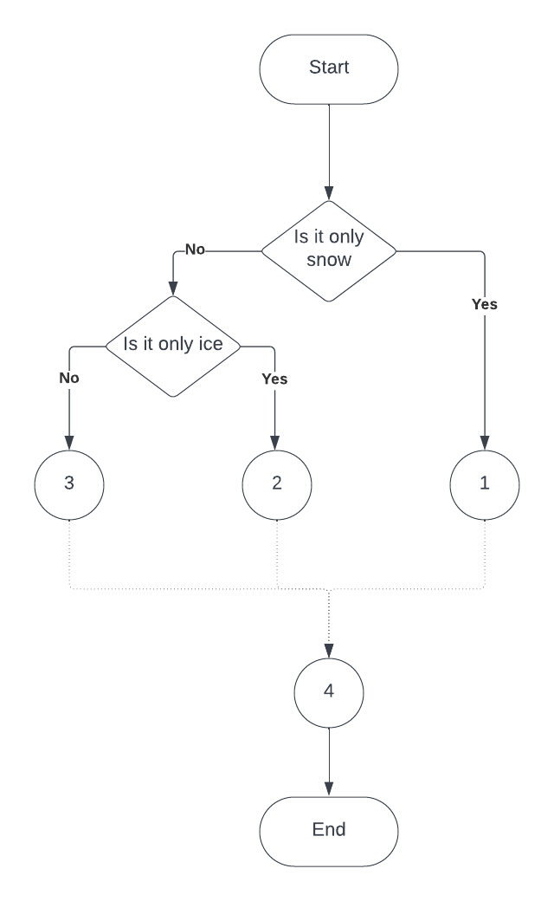

**Flowchart 1**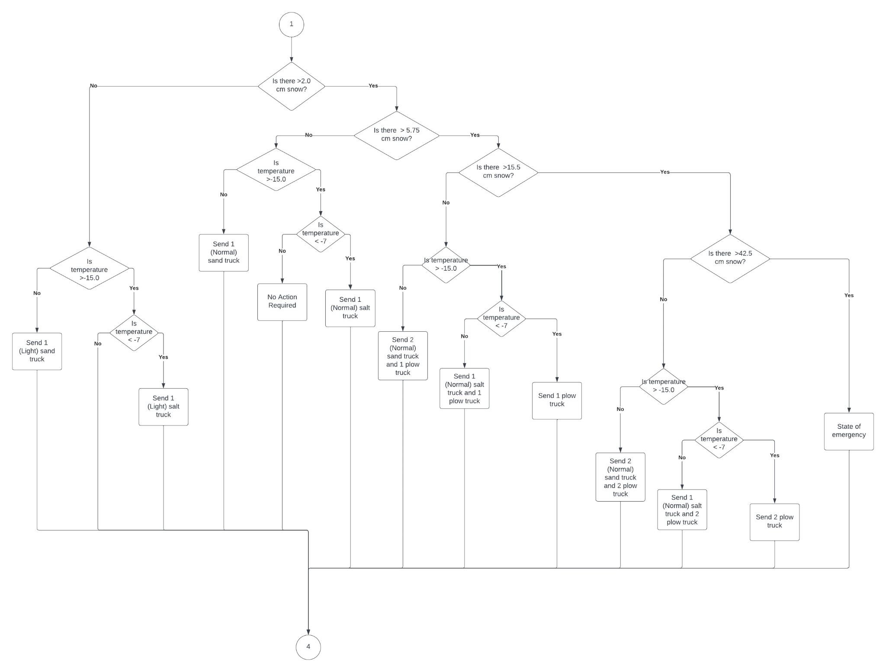

Flowchart 2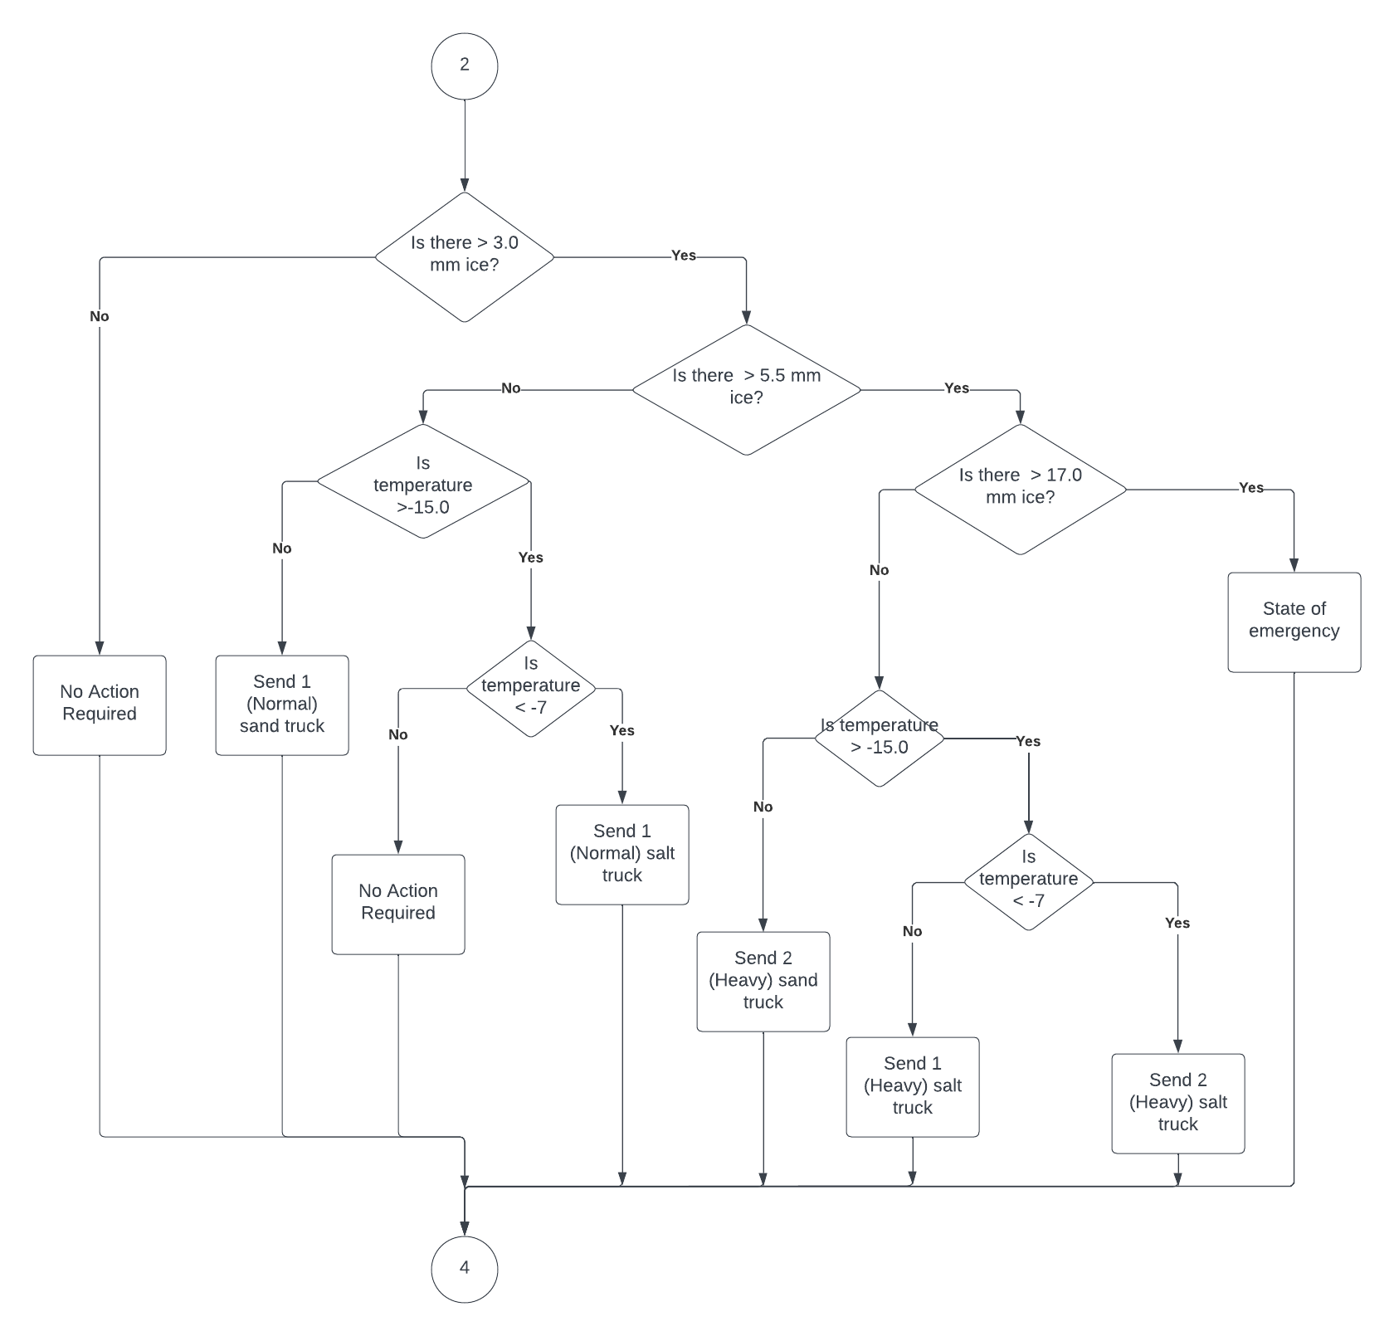

Flowchart 3 - Viktor Makarov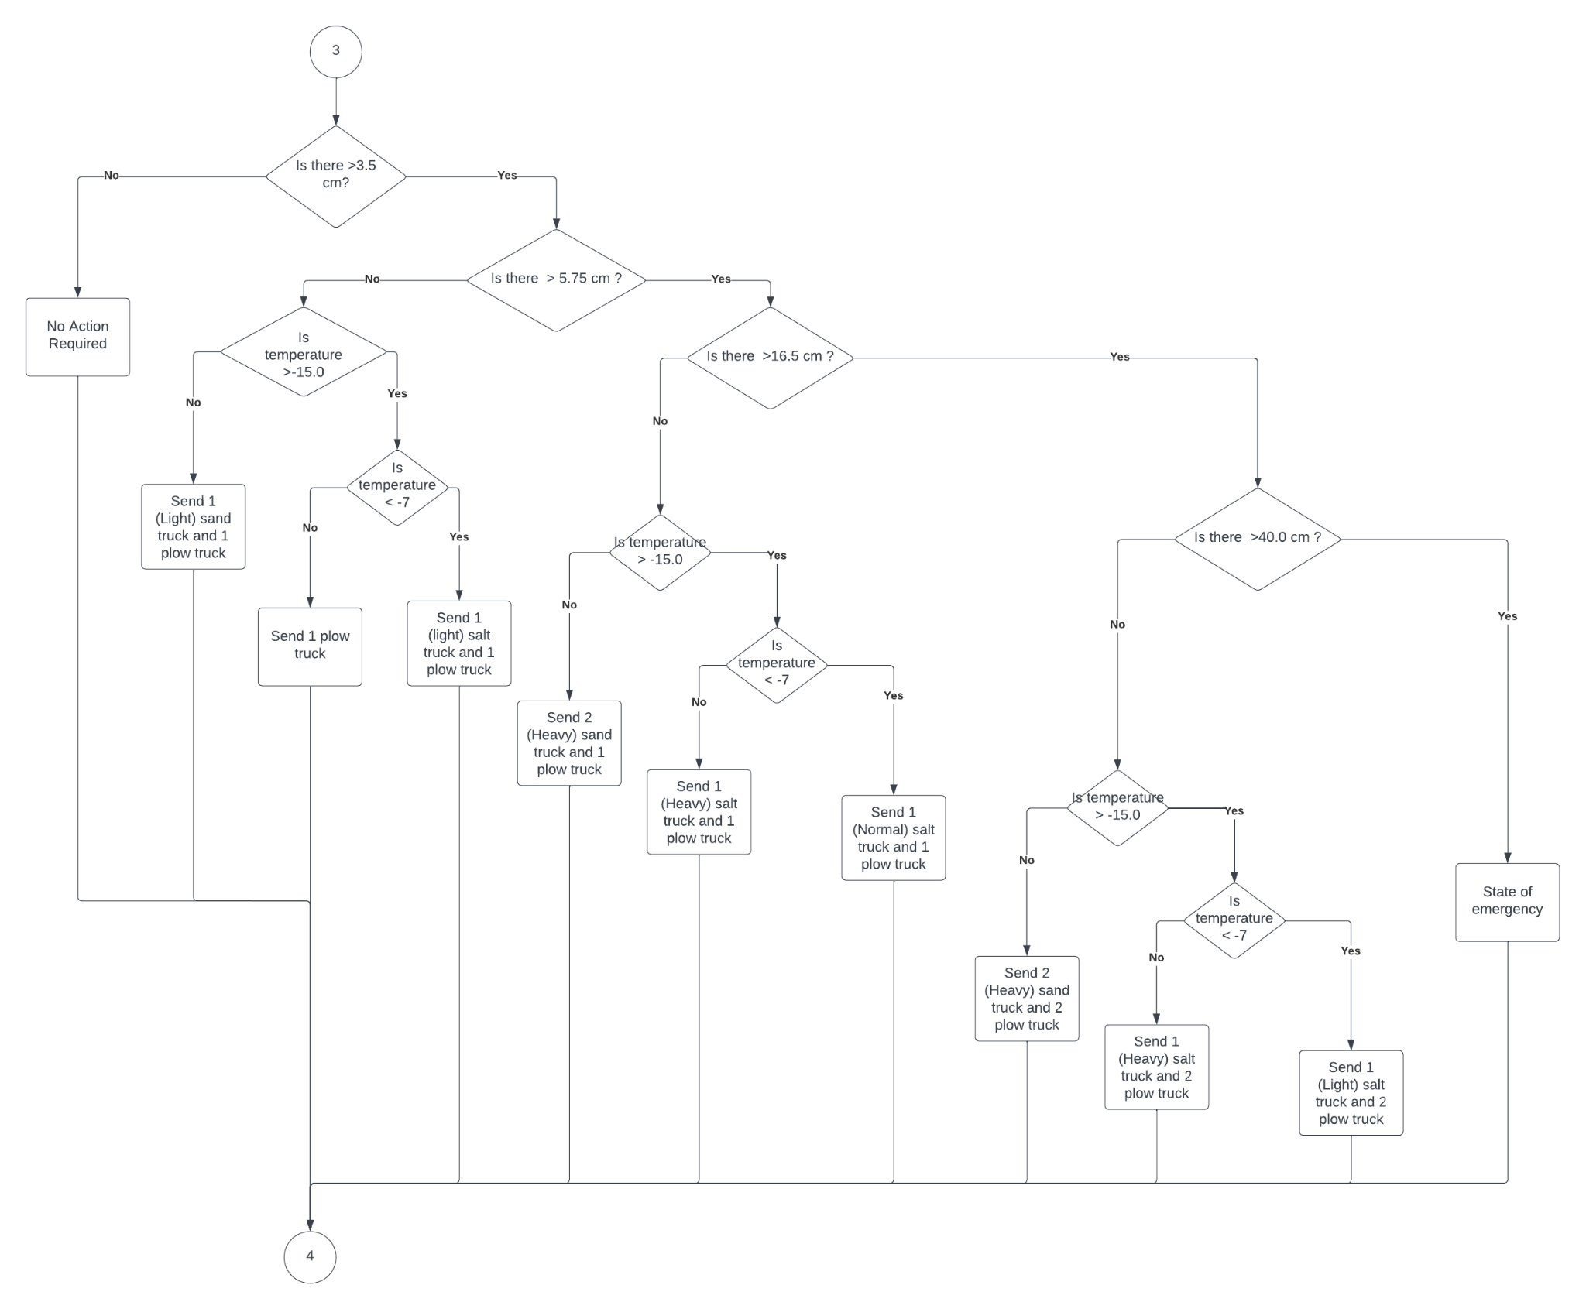

Test Logic

Condition ICE, 5 mm, -13 C

Start -> No, it is not only snow -> yes, it is only ice - > Yes, more than 3mm -> No, less than 5.5 mm - > No, its warmer that -15 -> Yes, it's colder than -7 - > Send 1 normal salt truck -> End

Describe Logic 3

Main idea of this solution is to ask a bunch of questions to find the answer. The solution is the list of questions that provide necessary information about weather conditions. After questions, the program does action from the table (for instance, send a truck).